**INDUSTRY-SPECIFIC INTELLIGENT FIRE MANAGEMENT SYSTEM**

# Entice Enter Engage



How does someone What do people In the core moments initially become aware experience as they in the process, what of this process? begin the process? happens?

**Steps INSTALLATION**   **GUIDANCE &**

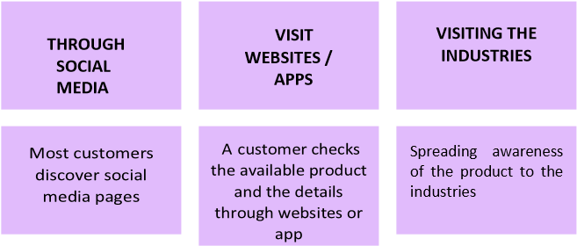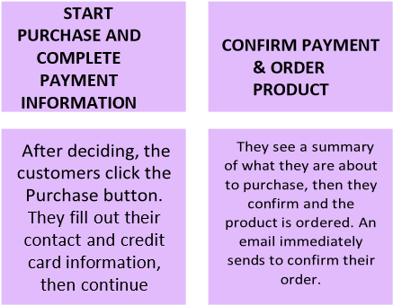

What does the person (or group) **OF THE TESTING CONTROL MEASURES**

**PRODUCT** typically experience?

The product is delivered The customer is guided on Once the fire is detected the alarm and notification is sent

and installed in the how to use the product by to the authority via message. industries. the seller. After the installation, the product is The sprinklers and exhaust fans are automatically



tested and if any defect is switched on. detected, it is replaced.

## Interactions

What interactions do they have at

each step along the way? Reaching out to Discussing with the



Contacting the customer

service in case of

emergency.



Customers getting to know

on how to operate the

system from the guide.



Contacting the

customer care to

track the status of the

product.



Product ordering

section of the

website/app.

people who are guide the familiar with the appropriate place to



**People:** Who do they see or talk to? product. install

**Places:** Where are they?

**Things:** What digital touchpoints or physical objects would they use?



Monitoring the

technical setup.



Connecting

the technical

setup with the app.



Accessing the website



Helping them to

install the fire

management

system.

**Goals & motivations** Helping the Helping the customers

customers to to save human lives

At each step, what is a person’s prevent fire and properties. accidents. primary goal or motivation? (“Help



me...” or “Help me avoid...”)



Guides tend to

be too good that

people

are

reassured when

they meet their

guide.

## Positive moments Customers are Feels good with the

What steps does a typical person happy with the product. product and theoutcome. find enjoyable, productive, fun, motivating, delightful, or exciting?



## Negative moments



Customers are

anxious

and

doubtful initially



They think that the

system is complex



Some customers are

afraid of investing

the money



Lack of patience



Shows no interest in

studying the details

of the product.



The customers need

support but at the

same time

afraid.

What steps does a typical person find frustrating, confusing, angering, costly, or time-consuming?

## Areas of opportunity Ho



The customer

should not be

negligent of the

notification.



The notification

should be as quick

as possible.



Making sure that

the sensors are

connected to the

apps properly.



The installation of

the system should

be done faster.



It is essential for the

customers to make

use

of the product

once the solution

has been figured out



The customers

should not hesitate

to invest on the

product.

How might we make each step w better? What ideas do we have? What have others suggested?

# Exit

What do people typically experience as the process finishes?



This system prevents the

fire accidents at the initial

stage itself which will

avoid the losses of assets.



**PREVENTION**



**SAFE AND**

**SECURE**

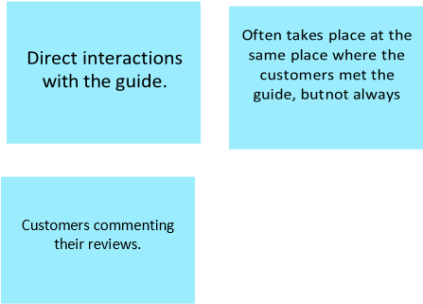



Helping the customers to

feel confident at the

workplace



Making the

customers to feel

safe and secured.



Controlling the fire

soon after the

detection



The customers

find

it difficult to manage

the technical setup

.



The sprinklers

should automatically

work to protect the

assets



The sensors should

be active once

switched on to

control the fire.

TEAM MEMBERS:**TEAM ID :**



**PNT2022TMID42466**

# Extend

What happens after the experience is over?



The satisfied customers

suggest

the product to

the other industries.



As the system is easy

to

operate it is considered

to be user friendly.



It is essential that the

product is handled well and

with care.



**HANDLE**

**WITH CARE**



**USER**

**-**

**FRIENDLY**



**SUGGESTIONS**

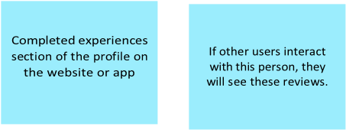



Helping them to

update the

system



Safeguarding the

properties and

human lives.



The

y are less aware

of the notification

.



The customers

should immediately

inform the service

center to

replace

the product in case

of defect.



The customer

should give honest

feedbacks.